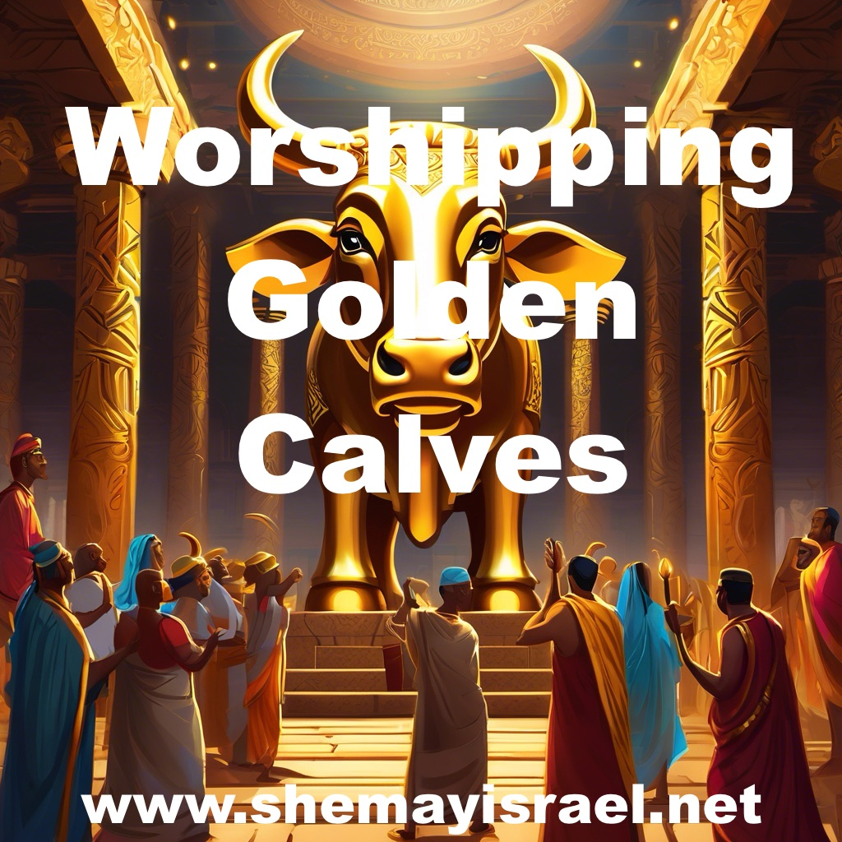

Written by: Todd D. Bennett

This article was originally published as a weekly newsletter on Day 30 of Month 12 on the Creator’s calendar, also known as March 1, 2025 on the Roman calendar. It is also Adar 1, 5785 on the calendar of the Rabbis and Ramadan 1, 1446 AH on the Muslim calendar.

Well, it seems as though I have to make a choice when sending these Newsletters out. Apparently for the fonts to all convert the hyperlinks get turned off. For the hyperlinks to work, the fonts do not translate. I tried to get the links to work in the last email but the Name of hwhy displayed as hwhy. So here is the version with the proper fonts, but the links do not work.

While the first crescent moon was sighted in Texas, and other locations in the United States last night, it was not visible in Jerusalem. We mark time at the location chosen by the Creator of time, based upon the Appointed Times that designate a specific place for the observance of those times. The Torah Calendar site uses Jerusalem as the starting point and that is why you will see a day difference this month.

This week, I returned from the Land of Midian and Edom to my current residence in exile. If I were still in Edom, I would have looked up last night to a sky with no first sliver. It will be visible tonight in the Covenant Land and the surrounding region, after Shabbat.

As a result, since hwhy would not be observing Day 1 of Month 13 until after sunset on Shabbat, I do not feel it is appropriate to get ahead of Him.

I know that it can get confusing for those in exile. That is one of the reasons why we look forward to leaving Babylon someday, going home and dwelling in the presence of hwhy. Being in complete synchronicity with Him and His ways should be our ultimate desire.

In case you missed my updates, I had an amazing trip to Saudi Arabia and Jordan. I hope that you have seen some of the short posts that I uploaded to X and YouTube. If not, maybe you would consider subscribing to my channels on those platforms. I’m going to try to spend more time posting, especially since I am finally finished The Israel Dilemma book.

Earlier this week I posted a short video showing the golden calf altar. It was amazing to visit this site in the shadow of Mount Sinai. In fact, it was located in between the Mountain and what is believed to be the camp of Yisrael on a huge flat plain.

Here is the link if you haven’t seen it.

That altar is just one piece of the cumulative evidence in the region that points to the exodus of the Yisraelites from Egypt into the Land of Midian. From the crossing site in the Gulf of Aqaba to the split rock of Horeb, and even the Amalekite battle site near the split rock filled with arrowheads and sling stones.

That was likely the spot where Moses held the rod up while Aaron and Hur supported his hands and Joshua fought below. One of our group actually located a petroglyph that seemed to depict that event.

Interestingly, the text is clear that Aaron and Hur helped raise up both hands of Moses while he was holding the rod on top of a hill. If that is the case, it is very plausible that Moses was holding the wood in both hands with a man on each side of him, using the rod as a support. Can you see the physical picture presented here? It is especially profound that Joshua was down below fighting and would only be successful if Moses maintained the position of the cross. What a prophetic visual pattern of the future.

We then see Jabal al Lawz with a blackened top and a ceremonial site below. There is even a cave directly above what is referred to as Moses’ Altar that is connected to the event described in 1 Kings 19 when Elijah fled to Horeb – the Mountain of Elohim.

Nearby there is the Golden Calf Altar and beyond that is an enormous plain where Yisrael likely camped. Then add to that the mass grave site that would have been required after the sin of the golden calf event and you have overwhelming evidence of the events described in the Scriptures.

It seems almost unbelievable that the world has been looking in the wrong place for centuries, but it really shouldn’t surprise us. Many of us were misdirected on our journey. That is what the enemy and most religion tries to do, misdirect and point people away from truth. I hope to put together a short video with a map showing the locations of these sites to give you a better understanding.

It’s not only the site locations and their proximity to Mount Sinai and one another, but also the petroglyphs contained at some of these locations that add to their impact.

I also posted a video on what appears to be a boundary marker below the Mountain in accordance with Exodus 19.

“¹² You shall set bounds for the people all around, saying, Take heed to yourselves that you do not go up to the mountain or touch its base. Whoever touches the mountain shall surely be put to death. ¹³ Not a hand shall touch him, but he shall surely be stoned or shot with an arrow; whether man or beast, he shall not live. When the Shofar sounds long, they shall come near the mountain.” Exodus 19:12-13

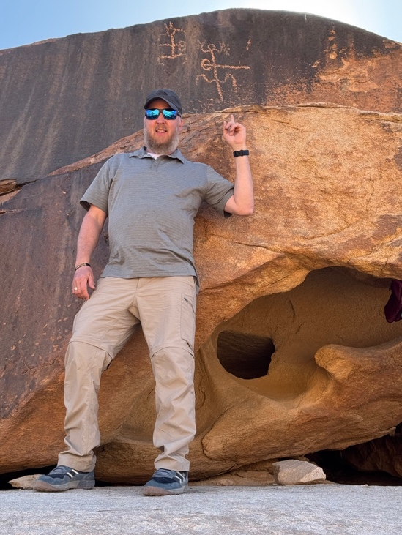
There is also an ancient petroglyph showing a man and a woman being impaled. Now whether this depicts an event before the golden calf incident or after is not clear. Again, it clearly fits the narrative of what happened then and shows the consequences of disobedience.

It is important to understand that if you follow the Messiah of Yisrael named Yahushua, then you are trusting in the Son of the Father hwhy. He is the same Father that executes judgment and dealt severely with people who did not meticulously follow His instructions.

It brings to light the reality of what happened at this location. What was supposed to be a joyous wedding celebration turned into a somber funeral. I showed that in my video examining The Cemetery of the 3,000.

Of course, that begs the question: Why would the people do such a thing?

Well, sometimes it is helpful to take a step back and consider their perspective. These people were all born in Egypt, and they were filled with Egyptian culture and traditions.

They came out of Egypt but that doesn’t mean that Egypt came out of them. They had been surrounded by Temples to the gods and great images of those gods. That is how many of them understood worship – especially those in the mixed multitude that joined Yisrael.

They were brought out of Egypt in spectacular fashion. They underwent some tests that they failed. hwhy was trying to show them that He would be a Husband and a provider to them. He was not like Pharaoh who enslaved them. He liberated them and would provide for all of their needs, not necessarily their wants. They needed to learn to follow Him, obey Him and trust Him.

They had entered into a covenant relationship at Passover and that allowed them to be delivered, but they still needed to consummate the relationship through a wedding at Sinai on Shavuot – the fiftieth day that reminds us of the Jubilee every year.

Seventy (beings) originally went into Egypt and twelve (tribes) came out. That revealed the pattern of gathering a people called Yisrael (12) from the Nations (70) through the Appointed Times.

Remember that the final Feast of Sukkot involves the sacrifice of 70 bulls. I repeatedly remind people that the bull represents Joseph, and the fulfillment of Sukkot, and the cycle of the Appointed Times, involves the regathering of Joseph from the Nations.

After all of the amazing acts of deliverance and provision, why would the people do something that was so wrong, while Moses was completing the Marriage ceremony that had been paused after hwhy spoke the Ten Words?

It seems that they were amped up and ready for the next thrill. More pyrotechnics, explosions and earthquakes. More adrenaline and excitement.

Instead, they got nothing. Crickets.

What happened to that guy Moses? No one knew.

Well, they weren’t going to wait around forever. They grew impatient and they decided they were going to take matters into their own hands. So they took the bull by the horns - literally. They made an image of a golden calf.

Interestingly, they violated the eleventh Commandment

“²¹ So the people stood afar off, but Moses drew near the thick darkness where Elohim was. ²² Then hwhy said to Moses, Thus you shall say to the children of Yisrael: You have seen that I have talked with you from heaven. ²³ You shall not make anything to be with Me - gods of silver or gods of gold you shall not make for yourselves. ²⁴ An altar of earth you shall make for Me, and you shall sacrifice on it your burnt offerings and your peace offerings, your sheep and your oxen. In every place where I record My Name I will come to you, and I will bless you. ²⁵ And if you make Me an altar of stone, you shall not build it of hewn stone; for if you use your tool on it, you have profaned it. ²⁶ Nor shall you go up by steps to My altar, that your nakedness may not be exposed on it.” Exodus 20:22-25

It’s no coincidence that they stopped at ten and then violated the eleventh. They asked for the mediator and hwhy granted their request. They then decided not to wait for that mediator to complete the process, and they started building their own form or worship.

“¹ Now when the people saw that Moses delayed coming down from the mountain, the people gathered together to Aaron, and said to him, Come, make us gods that shall go before us; for as for this Moses, the man who brought us up out of the land of Egypt, we do not know what has become of him. ² And Aaron said to them, Break off the golden earrings which are in the ears of your wives, your sons, and your daughters, and bring them to me. ³ So all the people broke off the golden earrings which were in their ears, and brought them to Aaron. ⁴ And he received the gold from their hand, and he fashioned it with an engraving tool, and made a molded calf. Then they said, This is your god, O Yisrael, that brought you out of the land of Egypt! ⁵ So when Aaron saw it, he built an altar before it. And Aaron made a proclamation and said, Tomorrow is a feast to hwhy. ⁶ Then they rose early on the next day, offered burnt offerings, and brought peace offerings; and the people sat down to eat and drink, and rose up to play.” Exodus 32:1-6

Now it is significant to point out that their intention was apparently to worship hwhy, or maybe Aaron was simply trying to sanctify their actions by declaring “Tomorrow is a Feast to hwhy.”

The problem is, they were doing it their way instead of His way. They wanted something familiar and physical. Something they could gaze upon and touch. Something tangible that they could experience. The problem is that their “play” involved vile and disgusting orgiastic behavior. They were supposed to be set apart to hwhy and they were acting like a bunch of pagans.

If you watch the video regarding the altar you can see the many depictions of Egyptian cow gods etched upon the stones. The Egyptians worshipped the Apis bull and Hathor.

Aside from mixing, which is specifically prohibited by hwhy, they were also declaring a Feast to hwhy at a time not prescribed by hwhy.

hwhy specifically spoke the Ten Words on Shavuot. That was a Feast Day.

So, they were doing it their own way, acting like a bunch of pagans at the wrong time. It sounds a lot like what many Christians are doing these days. Putting up Christmas Trees that represent the phallus of Nimrod defending their actions by declaring “that’s not what it means to me.” Celebrating the ancient fertility rite of Easter but calling it Resurrection Sunday. It’s all mixing and it’s all profane in the eyes of hwhy.

While people can have good intentions, it doesn’t mean that their actions do not anger hwhy. You can declare a sabbath or a feast to Him all you want, but if you refuse to follow Him according to His schedule, your actions are all vanity. Although hwhy is patient, He is still a just and jealous Elohim. If you chose to ignore Him and try to do it your own way, you can expect to suffer consequences.

From the sounds of the text of Exodus, it appears that the people started their “play” right before Moses was ready to descend from the mountain.

“⁷ And hwhy said to Moses, Go, get down! For your people whom you brought out of the land of Egypt have corrupted themselves. ⁸ They have turned aside quickly out of the way which I commanded them. They have made themselves a molded calf, and worshiped it and sacrificed to it, and said, This is your god, O Yisrael, that brought you out of the land of Egypt! ⁹ And hwhy said to Moses, I have seen this people, and indeed it is a stiff-necked people! ¹⁰ Now therefore, let Me alone, that My wrath may burn hot against them and I may consume them. And I will make of you a great nation. ¹¹ Then Moses pleaded with hwhy his Elohim, and said: hwhy, why does Your wrath burn hot against Your people whom You have brought out of the land of Egypt with great power and with a mighty hand? ¹² Why should the Egyptians speak, and say, He brought them out to harm them, to kill them in the mountains, and to consume them from the face of the earth? Turn from Your fierce wrath, and relent from this harm to Your people. ¹³ Remember Abraham, Isaac, and Israel, Your servants, to whom You swore by Your own self, and said to them, I will multiply your descendants as the stars of heaven; and all this land that I have spoken of I give to your descendants, and they shall inherit it forever. ¹⁴ So hwhy relented from the harm which He said He would do to His people. ¹⁵ And Moses turned and went down from the mountain, and the two tablets of the Testimony were in his hand. The tablets were written on both sides; on the one side and on the other they were written. ¹⁶ Now the tablets were the work of Elohim, and the writing was the writing of Elohim engraved on the tablets. ¹⁷ And when Joshua heard the noise of the people as they shouted, he said to Moses, There is a noise of war in the camp. ¹⁸ But he said: It is not the noise of the shout of victory, nor the noise of the cry of defeat, but the sound of singing I hear. ¹⁹ So it was, as soon as he came near the camp, that he saw the calf and the dancing. So Moses’ anger became hot, and he cast the tablets out of his hands and broke them at the foot of the mountain.” Exodus 32:7-19

If they had only waited a little longer.

We could all take a lesson from this.

In this fast paced world that we live in, people have a hard time waiting. Everything is geared toward being fast. A friend of mine just posted a blog on the drive thru service mentality that really hits the mark. You can check it out at this link.

A lot of people are guilty of this sort of behavior. We are used to getting what we want, when we want it. We are not used to waiting, but that is what hwhy wants us to understand and accept.

If we truly follow Him, then we are on His time, not our time. It is not about what is convenient for us, but rather what He commands. That is true whether you have a community of followers or you are all alone, like Elijah in the cave at Horeb.

I had a wonderful telephone call with an Amish Brother from Arkansas yesterday before Shabbat. He wrote me a letter and asked to speak to me about his current situation. Seven years ago, he understood that he needed to keep the seventh day Sabbath instead of the Catholic Sunday observance.

Well, he ended up getting banned by his elders, which means that the entire community turned their back on him. They won’t have anything to do with him because he wants to follow hwhy with all his heart.

Now most of us have left churches or received “the right foot of fellowship” due to our desire to diligently follow the Instructions, but it’s much different for someone woven into the fabric of a close-knit Amish community. The Elders have turned his family, friends and neighbors against him and have even kidnapped his children.

They say they are doing this because he is going to hell for observing the sign of the Covenant, rather than the sign of the church.

Please keep brother Myron in your prayers. May hwhy give him the strength to persevere and a powerful victory over his oppressors who claim to be Christian leaders.

I reminded him that this is the very same religious spirit that the Pharisees operate under, and I suspect that Christian Zionists will likely end up turning on those who do not agree with their position concerning Israel.

It makes me think of the words of Yahushua:

“³⁴ Do not think that I came to bring peace on earth. I did not come to bring peace but a sword. ³⁵ For I have come to set a man against his father, a daughter against her mother, and a daughter-in-law against her mother-in-law; ³⁶ and a man’s enemies will be those of his own household. ³⁷ He who loves father or mother more than Me is not worthy of Me. And he who loves son or daughter more than Me is not worthy of Me. ³⁸ And he who does not take his execution stake and follow after Me is not worthy of Me. ³⁹ He who finds his life will lose it, and he who loses his life for My sake will find it.” Matthew 10:34-39

Sometimes we need to make choices that hurt and separate, but those choices test our priorities.

My trip to Sinai obviously brought my focus to Passover and the patterns of the Appointed Times that we are supposed to be rehearsing, at the right time, to keep us focused on hwhy and His Covenant Plan. The question everyone must ask is will you keep the times at His time according to His instructions?

As we approach Passover our focus should be on a couple of things. We know the identity of the Lamb of Elohim that was patterned through the Passover rehearsal, and we are waiting for His return, but we are also waiting for our deliverance.

Remember this prophecy from Jeremiah?

“¹⁴ Therefore behold, the days are coming, says hwhy, that it shall no more be said, hwhy lives who brought up the children of Yisrael from the land of Egypt, ¹⁵ but, hwhy lives who brought up the children of Yisrael from the land of the north and from all the lands where He had driven them. For I will bring them back into their land which I gave to their fathers.” Jeremiah 16:14-15

Last Passover we were still commemorating the exodus from Egypt. That means we are still waiting for the fulfillment of this promise. We are still waiting for the greater Exodus and a return to the Covenant Land.

That poses a dilemma for all the Christian Zionists who believe that the Covenant Land belongs to the Jewish people who are currently occupying the Land.

That fulfillment of the prophecy in Jeremiah will be through the Mediator who ascended into the clouds. We are still waiting for our Mediator and some people have begun building golden calves.

We are at the end of the 40 Jubilee years since Yahushua ascended - we are right at the door step. We need to be patient and wait for the King. W cannot make the same mistake as the 3,000.

Egypt and Babylon want to ensnare you and draw you away from hwhy. They do this by utilizing the doctrine of Balaam. If the enemy can get you to act outside of the will of hwhy and then fall under His wrath, then mission accomplished.

I see people who took the bait with the State of Israel. They are growing impatient. They want to take action and hasten His coming, even if their actions will place them in the bull’s eye. No pun intended.

Many Christians have made a couple golden calves out of the Jewish people and the Jewish State which both completely ignore the Messiah.

I saw a post last week about the bus bombings in Israel and they declared that it was on the same level as splitting the Red Sea. Really?

Let me be clear. Three empty buses parked overnight that exploded into flames due to setting the timers wrong is not even close to the miracle of the parted sea.

Now thankfully, no one was hurt in those empty bus explosions, but that event pales in comparison to the miracles of the Exodus that were a demonstration of the Mighty Hand of hwhy.

We haven’t seen that in awhile and people are confusing the Iron Dome and MOABs made in America and dropped by the IDF with the judgment of Elohim.

These people are probably already celebrating Saturnalia and Easter, as well as the day of the sun on the calendar of the anti-Christ. They likely do not know the Name of hwhy or the Messiah Who they claim to follow. And they probably reject His Torah and believe it was abolished. So they are lawless.

These are very serious issues because these people are ripe for deception. If they cannot even get the basics of their faith straight, then they are susceptible to all sorts of lies, because they are not grounded on the Rock.

In fact, they are already deceived on a grand scale. It’s only going to get worse as more “miracles” take place through the mighty hand of Donald Trump and the United States of America.

How about Secretary of Defense Pete Hegseth. Remember the guy with the giant crusader cross tattooed to his chest?

“Speaking at an event in Jerusalem in 2018 he said there was ‘no reason why the miracle of re-establishing the temple on the Temple Mount isn’t possible’, using the Israeli name for the raised plateau in occupied East Jerusalem where Al-Aqsa Mosque stands.”

He equated that future event with other “miracles” associated with the Presidency of Donald Trump, such as moving the U.S. Embassy to Jerusalem and annexing the Golan Heights. Of course, these people also look that the Rothschilds’ and United Nations’ establishment of a Zionist Jewish State in the Covenant Land as a miracle as well.

If Donald Trump gives the green light for the Pharisees to build another temple, I suspect that many people will place that in the miracle category also.

So people are claiming miracles as they build their golden calves while Yahushua the Mediator tarries, just like Moses tarried.

It is important to understand that the Yahudim turned the Temple into an idol before it was destroyed by the Babylonians.

That is why the Prophet Jeremiah declared:

“¹ The word that came to Jeremiah from hwhy, saying, ² Stand in the gate of hwhy’s house, and proclaim there this word, and say, Hear the word of hwhy, all you of Yahudah who enter in at these gates to worship hwhy! ³ Thus says hwhy of hosts, the Elohim of Yisrael: Amend your ways and your doings, and I will cause you to dwell in this place. ⁴ Do not trust in these lying words, saying, The Temple of hwhy, the Temple of hwhy, the Temple of hwhy are these. ⁵ For if you thoroughly amend your ways and your doings, if you thoroughly execute judgment between a man and his neighbor, ⁶ if you do not oppress the stranger, the fatherless, and the widow, and do not shed innocent blood in this place, or walk after other gods to your hurt, ⁷ then I will cause you to dwell in this place, in the land that I gave to your fathers forever and ever. ⁸ Behold, you trust in lying words that cannot profit. ⁹ Will you steal, murder, commit adultery, swear falsely, burn incense to Baal, and walk after other gods whom you do not know, ¹⁰ and then come and stand before Me in this House which is called by My Name, and say, ‘We are delivered to do all these abominations’? ¹¹ Has this House, which is called by My Name, become a den of thieves in your eyes? Behold, I, even I, have seen it, says hwhy. ¹² But go now to My place which was in Shiloh, where I set My Name at the first, and see what I did to it because of the wickedness of My people Yisrael. ¹³ And now, because you have done all these works, says hwhy, and I spoke to you, rising up early and speaking, but you did not hear, and I called you, but you did not answer, ¹⁴ therefore I will do to the house which is called by My name, in which you trust, and to this place which I gave to you and your fathers, as I have done to Shiloh. ¹⁵ And I will cast you out of My sight, as I have cast out all your brethren - the whole posterity of Ephraim. ¹⁶ Therefore do not pray for this people, nor lift up a cry or prayer for them, nor make intercession to Me; for I will not hear you. ¹⁷ Do you not see what they do in the cities of Yahudah and in the streets of Jerusalem? ¹⁸ The children gather wood, the fathers kindle the fire, and the women knead dough, to make cakes for the queen of heaven; and they pour out drink offerings to other gods, that they may provoke Me to anger. ¹⁹ Do they provoke Me to anger? says hwhy. Do they not provoke themselves, to the shame of their own faces? ²⁰ Therefore thus says Adonai hwhy: Behold, My anger and My fury will be poured out on this place - on man and on beast, on the trees of the field and on the fruit of the ground. And it will burn and not be quenched.” Jeremiah 7:1-20

This is hwhy speaking through His Prophet to His Covenant people who were about to be punished and removed from the Covenant Land.

Did you notice the “if-then” correlation between conduct and living in the Land? Did you also notice the treatment of others that hwhy requires from His people.

He expects no less from His people today.

hwhy allowed the Babylonians to destroy that Temple just like He previously allowed the Philistines to destroy the Mishkan at Shiloh, and He later allowed the Romans to destroy the Second Temple.

That’s three times. You would think that people would get the hint. Like “three strikes and you’re out.”

hwhy is not interested in buildings made by men. In my latest book I detailed the failed efforts to rebuild the Temple under the Roman Emperor known as Julian the Apostate in the Fourth Century CE. hwhy shut it down in spectacular fashion.

I can assure you that many people are going to be deceived if and when the altar and/or another temple get built. They will turn it into an idol.

Sadly, many of these people are still in the exile because of the House of Yisrael that built two golden calves. It’s hard to believe, but true. After the division of the Kingdom of Yisrael, the Northern Tribes, led by Joseph, set up a false system of worship involving not one, but two golden calves.

Of course, Joseph was a bull so how fitting that Joseph would resort to worshipping the bull. We must learn from the mistakes of the past instead of repeating them.

Like I said, while in Saudi Arabia, I visited the cemetery of the 3,000, which likely contains more than 3,000 remains, because the number mentioned in the Scriptures may have simply been the men. It could have been many more, and it was a sobering reminder of the penalties associated with sin.

Here is the account:

“²⁵ Now when Moses saw that the people were unrestrained (for Aaron had not restrained them, to their shame among their enemies), ²⁶ then Moses stood in the entrance of the camp, and said, Whoever is on hwhy’s side - come to me! And all the sons of Levi gathered themselves together to him. ²⁷ And he said to them, Thus says hwhy Elohim of Yisrael: Let every man put his sword on his side, and go in and out from entrance to entrance throughout the camp, and let every man kill his brother, every man his companion, and every man his neighbor. ²⁸ So the sons of Levi did according to the word of Moses. And about three thousand men of the people fell that day.” Exodus 32:25-28

This event was intimately connected with Sinai and the wedding ceremony associated with that Feast. The people committed idolatry (adultery) while Moses was up on the Mountain receiving the Ketubah – the Marriage Contract.

Yahushua came looking for the lost sheep of the House of Yisrael who were scattered because of their adulterous conduct. He came searching for an adulterous bride who was willing to repent. The price to redeem that Bride was His own life and His shed blood.

That was the message that we were supposed comprehend, and the connection that we were supposed to make with another event involving 3,000 that occurred in Jerusalem on Shavuot shortly after the ascension of Yahushua.

“³⁶ Therefore let all the House of Yisrael know assuredly that Elohim has made this Yahushua, whom you crucified, both Master and Messiah. ³⁷ Now when they heard this, they were cut to the heart, and said to Peter and the rest of the apostles, Men and brethren, what shall we do? ³⁸ Then Peter said to them, Repent, and let every one of you be immersed in the Name of Messiah Yahushua for the remission of sins; and you shall receive the gift of the Set Apart Spirit. ³⁹ For the promise is to you and to your children, and to all who are afar off, as many as our Elohim will call. ⁴⁰ And with many other words he testified and exhorted them, saying, Be saved from this perverse generation. ⁴¹ Then those who gladly received his word were immersed; and that day about three thousand souls were added to them. ⁴² And they continued steadfastly in the apostles’ doctrine and fellowship, in the breaking of bread, and in prayers. ⁴³ Then fear came upon every soul, and many wonders and signs were done through the apostles. ⁴⁴ Now all who believed were together, and had all things in common, ⁴⁵ and sold their possessions and goods, and divided them among all, as anyone had need. ⁴⁶ So continuing daily with one accord in the Temple, and breaking bread from house to house, they ate their food with gladness and simplicity of heart, ⁴⁷ praising Elohim and having favor with all the people. And hwhy added to the assembly daily those who were being saved.” Acts 2:36-47

I like to remind people that Peter, the Apostles and the 3,000 who were immersed in the Name of Yahushua were on the calendar provided through the Torah.

They were at the House of Elohim that was soon to be destroyed in that generation. Nevertheless, that was still the place designated by hwhy to meet Him. He never chose to place His Name at the Dead Sea.

And guess what? They kept going to the Temple daily. They didn’t venture out to the Dead Sea and start following some alleged Zadokite Priests on a profaned solar calendar. They remained in the community in Jerusalem.

Peter, James and John, by their very conduct, destroy the narrative that is becoming popular with many concerning the so-called Zadok Priestly Calendar. And, of course, the Set Apart Spirit is the ultimate witness. The Spirit fell as tongues of fire on those meeting in Jerusalem at the Appointed Time on the correct calendar.

There are a lot of people playing with strange fire as they stand with Israel and dabble with rogue solar calendars that do not comply with the Torah.

I don’t want to be found “playing” when the Master descends from the clouds. I want to be among those who are following His timing and sealed by the Set Apart Spirit.

I hope that you are too!

That is why we must not be found building idolatrous temples or worshipping golden calves when the Master descends to gather His elect – His chosen people Yisrael.

Berakhot

Todd
www.shemayisrael

PS: I want to thank you all for your prayers and support while I was away! The trip to Sinai was an incredibly important experience for me and my research. I hope to set up a tour in the future. If anyone is interested please let me know so I can assess the viability of such a trip.

Shema Yisrael (Hear O Yisrael) are the words that Yahushua spoke when asked what was the First Command.

“The first of all the Commandments is: ‘Hear, O Yisrael,
hwhy our Elohim, hwhy is one.”
Mark 12:29

“He who has ears to hear, let him hear!”
Matthew 11:15

Exodus 17:8-13
Exodus 32:5
See Revelation 2:14
Middle East Eye, Next US defense secretary Pete Hegseth called for new Jewish temple at Aqsa

